|  |
| --- |
| Instructure Inc |
| Phase II: eSchool Dashboard Enhancements |
| This change order is governed by Instructure Professional Services General Terms and Conditions provided in SOW: District School Board of Pasco County, Instructor Resources Dashboard May 27th, 2014 |

|  |
| --- |
| Oxana Barth  5/26/2015 |

**Project Summary:**

eSchool Dashboard custom software solution (LTI) was developed for district School Board of Pasco County, eSchool to extend Canvas LMS teacher and student interaction options. The LTI solution offers a comprehensive set of features that allows an end user to record student demographic information and monitor student course performance. The project consists of two phases. Phase I: “Development of the Teacher Resource Dashboard” included initial development and support of the solution and was completed in September 2014. Phase II: “eSchool Dashboard Enhancements” was started in May 2015 and is currently in progress. All Phase II milestones that are currently either in progress or scheduled are outlined in the billing schedule. All Phase II milestones are considered to be the continuous work, all billing is covered under this Change Order which is an extension to original SOW signed on 5-27-2014.

**Billing Schedule:**

Phase II Milestones

|  |  |  |  |  |  |  |  |
| --- | --- | --- | --- | --- | --- | --- | --- |
| **Milestones** | | **Billing Amounts** | | | **Milestone Status** | |  |
| 1. Multi-select section filter for Sections field | | $ 4,550 | | | Scheduled |  | |
| 2. Transition Contact Type Object from Canvas to Dashboard | | $ 6,000 | | | Scheduled |  | |
| 3. New Field in eSchool Dashboard: Comment | | $ 3,850 | | | Scheduled |  | |
| 4. eSchool Dashboard Dynamic Tables | | $ 10,500 | | | Scheduled |  | |
| *4.a. “Save as New” option for dynamic table* | | $ 6,000 | | | Scheduled |  | |
| *4.b “ Save as Default” option for dynamic table* | | $ 7,000 | | | Scheduled |  | |
| 5. New Ungraded Assignment View in Assignment Key LTI | | $ 6,000 | | | Scheduled |  | |
| 6. Improved Layout/Style for Wide Tables | | $ 2,450 | | | Scheduled |  | |
| 7. Rename White Pages and move it to Dashboard | | $ 437.50 | | | Scheduled |  | |
| 8. Student Dashboard | | $ 7,350 | | | Scheduled |  | |
| 9. Export User Contact Notes from Contact Info | | $ 3,000 | | | Scheduled |  | |
| 10. Add “ Add to Student Dashboard” and “Add to Teacher Dashboard” logic to admin portal “ Add Field” section | | $ 1,400 | | | Scheduled |  | |
| General Project Management Tasks [ overall project administration] | | $ 1,750 | | | Scheduled |  | |
| **Total** | **$ 60,287.5** | |  |  | | | |

**Project Total: $ 60,287.5**

Additional Subscription:

Assignment LTI application annual subscription cost $ 3,000

*Additional subscription covers annual support and maintenance for a new Assignment key LTI application. This application will be enhanced as a part of this project and will be released to client as soon as development is completed. See UAT dates for “New Ungraded Assignment View in Assignment Key LTI” milestone in the Development view. Annual subscription fee will be fully billed to client as soon as the application is available in client’s production environment.

* Development task order and order of deliverables are subject to change at development team discretion. All UAT dates are subject to change based on complexity of the tasks and availability of the development team.

Instructure will bill client by successful completion of each milestone outlined in Billing Schedule, any change in requirements during development cycle will be treated as a change order request. Change Order request should be thoroughly estimated by INSTRUCTURE Professional Services and billed to client according to current development rates.

All milestones outlined in Deliverables will be billed by time of their actual completion. Milestone is completed when the following conditions are met: programing is completed, internal testing is completed, and client received access to milestone in UAT environment.

General Project Management will be billed as soon as client signs off on each milestone in UAT environment and production schedule is finalized.

Client will be able to test the solution on the milestone basis. The following schedule will allow Instructure Professional Services to test and release milestones as they are ready for User Acceptance Testing.

Development Schedule:

|  |  |  |
| --- | --- | --- |
| Phase | Milestone | UAT Date * |
| **1. Development/Internal QA** |  |  |
|  | 1. eSchool Dashboard Dynamic Tables | **June 26th , 2015** |
|  | 1.a. “Save as New” option for dynamic table | **June 26th , 2015** |
|  | 1.b. “Save as Default” option for dynamic tables | **June 26th , 2015** |
|  | 2. Transition Contact Type Object to Dashboard from Canvas | **June 26th , 2015** |
|  | 3. Multi-select section filter for Sections field | **June 26th , 2015** |
|  | 4. New Field in eSchool Dashboard: Comment | **July 3rd, 2015** |
|  | 5. Add “ Add to Student Dashboard” and “Add to Teacher Dashboard” logic to admin portal “ Add Field” section | **July 3rd, 2015** |
|  | 6. Student Dashboard | **July 10th, 2015** |
|  | 7. Rename White Pages and move it to Dashboard | **July 10th, 2015** |
|  | 8. Improved Layout/Style for Wide Tables | **July 10th, 2015** |
|  | **9.** Export User Contact Notes from Contact Info | **July 17th, 2015** |
|  | 10. New Ungraded Assignment View in Assignment Key LTI | **June 26th, 2015** |
| **3. Production Release** |  | **TBD** |

|  |  |
| --- | --- |
| **INSTRUCTURE CONTACT**  **Name: Ian Morris**  **Role: Project Manager**  **Contact Info: 801.598.3293** [**ianm@instructure.com**](mailto:ianm@instructure.com) | **CLIENT CONTACT**  **Name: Michelle Lattke**  **Role: Project Manager/ LMS Administrator**  **Contact Info: 813. 346.1900,**  [**http://eschool.pasco.k12.fl.us**](http://eschool.pasco.k12.fl.us) |

**AUTHORIZATION**

__________________________________        ______________________________________      
CLIENT Authorized Signature INSTRUCTURE Authorized Signature  
  
JoAnne Glenn ______________________

Printed Name Printed Name  
  
Principal Pasco eSchool         ___________________________________

Title          Date   Title                                                       Date

**Addendum**

Business Requirements

1. Multi-select section filter for Sections field

Add ability to select multiple sections at a time

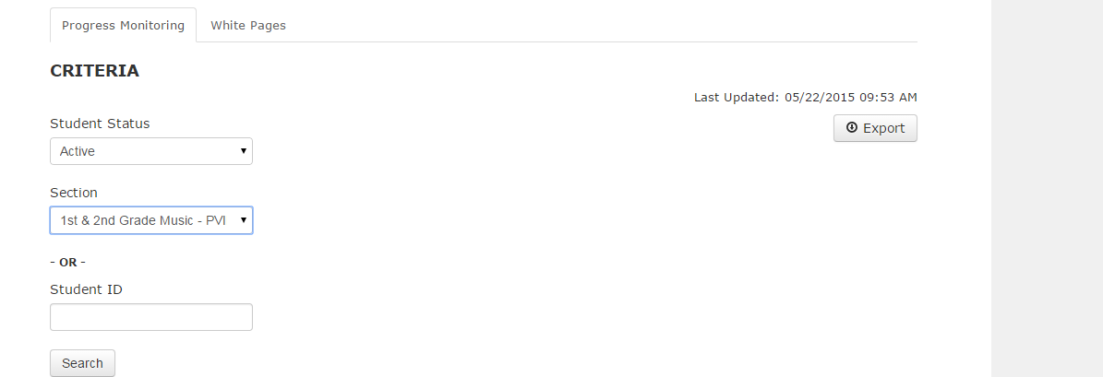

Current State:

User can select one section or the ALL option to display all sections; menu defaults to ALL sections, if no other selection is made

Future State:

User will be able to select from the following:

1. One Section
2. Many sections from the list
3. All

Menu still should default to ALL sections

2. Transition Contact Type Object to Dashboard from Canvas

Current Workflow:

1. User creates a message from the eSchool Dashboard

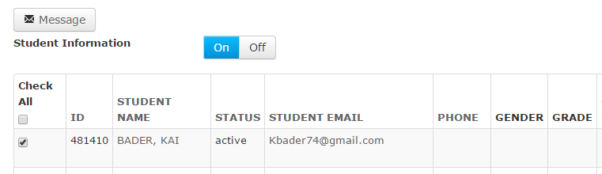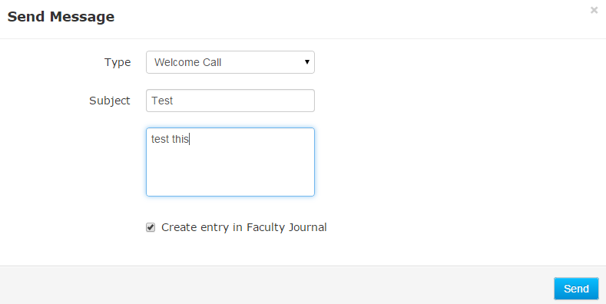

2. A new conversation message is created in Canvas for the student with the following Subject:

Course SIS ID_Welcome Call

OR

Course SIS ID_Phone Call

OR

Course SIS ID_Other

3. A new Faculty Journal Entry is created for the student. The message is sent with to the Faculty Journal with the following Subject Line:

Course SIS ID_Welcome Call

OR

Course SIS ID_Phone Call

OR

Course SIS ID_Other

Note: Message uses the Conversations API to create: 1. Message entry and 2. Faculty Journal entry at the same time

4. Overnight, the eSchool Dashboard gets updated with new information. The Canvas account report “User Note” is used to update certain eSchool Dashboard data. The “User Note” report provides the following information:

a. Student info [id, name]

b. Faculty Journal info [ date/time of the entry, message content, message subject]

6. User Note report data are parsed by eSchool Dashboard logic to calculate the following fields:

* + 1. Welcome Call = time/date stamp value captured on the “Welcome Call” Faculty Journal Entry subject line for the specific student. This value is linked to the student Journal Entry page
    2. Grace End = time/date stamp value, calculated based on Welcome Call date + 28 days.
    3. Last Phone Contact = time/date stamp value captured on the “Phone Call” Faculty Journal Entry subject line for the specific student

Phone contacts happen monthly. Each teacher will have numerous phone contacts for their course. The value displayed in this field is the most recent date/time stamp of the Journal Entry title that matches the naming convention.

Future Workflow:

*User Type: Teacher and Administrator*

1. User clicks on Message in the eSchool Dashboard (button text changed to Log/Message)



2. User selects a contact type and checks “Send Message” and/or   
“Log as Attempted Contact”



3. Student receives a Conversation Message in Canvas [only if send inbox message is checked]

4. A new user note record is created for that student in the Contact Info [“Attempted” is noted if “Attempted to Contact” was selected]

5. New Columns are available in the Student Interaction table. Additionally, new fields are available for Dynamic table field selection [only if administrator selected the option for those fields to show up in the Dashboard]



When clicking on Export Data button, user will be presented with option: “Contact Info Export” or Contact Notes” Export



6. Student Interaction Table and Contact Type Fields in Dynamic Views Logic:

a. All Contact Type Fields values : Welcome Call, Phone Call, Other [ new contact types] will have asterisk icon displayed by the timestamp value as soon as first “attempted” contact was registered.

b. All Contact Type Fields values will display date/time of actual contact NOT “ Attempted” contact

c. When user hovers over the asterisk above the Contact Type value: actual date/time the bubble message is displayed with all “Attempted” Contact Type date/time values

d. All Contact Type fields will show up in the Export csv file of the Dashboard

e. All Contact Types and other fields that use their data value to calculate the output e.g. Phone Call contributes to Grace End and Weeks Active calculation, should preserve their original color coding and calculation logic, only ACTUAL date/time values should be used to calculate output for those fields.

7. All Contact Type should be available in the Dashboard Export file



*User Type: Administrator*

1. Administrator goes to the eSchool Dashboard [course level] 🡪 Settings tab

2. Administrator adds new field by clicking on “Add Field” in Form Fields

3. Administrator checks the box “Contact Type”



4. Selects field Type: Date

This is a new value in the field type, Date doesn’t exist currently in Field Type

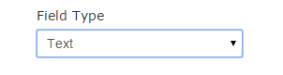

Date

5. Saves the field

**Output:**

1. New Contact Type was added to the message box. Message modal now has a new Contact Type (Phone Call S/B Default choice, and all other options in menu should be alphabetized above the “Other” choice)

2. New Contact Type field was added to Dynamic data field if “Add to Teacher Dashboard” is selected

3. Student Note modal has a new section designated for that Contact Type

4. New Contact Type field is a part of the EXPORT file for Dashboard

5. No color Coding will be available for new Contact Types but the rest of the fields will preserv their original color coding and calculation logic

6. Currently Welcome Call and Phone Call are linked to Faculty Journal page in Canvas, all links to Faculty Journal will be replaced with trigger to invoke the Contact Note pop-up that is currently available thru Contact Info page. User will be able to open the Contact Note pop-up by clicking on any Contact Type field value in dashboard [current: Welcome Call/Phone Call and newly added]

7. Contact Info Notes should not be available to students

8. Teacher and administrator will have access to Contact Notes thru Contact Info table

9. Teacher and Administrator will be able to Export Contact Notes from Contact Info Table; all values that are currently available in User Notes report [Canvas Account Report] should be available in the new Contact Notes Export.

**During transition to the new flow, Instructure will make sure:**

1. All old User Note Data such as welcome call, phone call, weeks active, grace end are all calculated/color coded correctly.

2. All old courses with welcome call, phone call, weeks active, and grace end data that rely on the Canvas Faculty Journal report will still show correct dates. All old values are preserved.

3. All new contact types are available in the Export file that is exported from dashboard landing page

3. New Field in eSchool Dashboard: Comment

Current State:

Teachers use Canvas Gradebook notes to leave any comments regarding student [ e.g. behavior pattern, preferences, etc.]

Future State:

Teachers and Admins will be able to use Comment field in eSchool Dashboard to capture comments related to a specific student enrollment.

The comment will be:

1. Always available only to user who left the comment

2. Edited multiple times in a threaded view, all additional comments are stacked

3. Only available at the enrollment level, not available in other courses

**Step 1:** Create a Comment





**Step 2:** View/Edit the Comment





**Note:**

* Comment could only be saved for a specific enrollment therefore it will only be available at course level and will not be available thru Contact Info Notes
* Comment Field will be available as a dynamic field

4. eSchool Dashboard Dynamic Tables

Current State:

All eSchool Dashboard Tables are static, they are displayed on the Progress Monitoring Tab landing page in the following way:

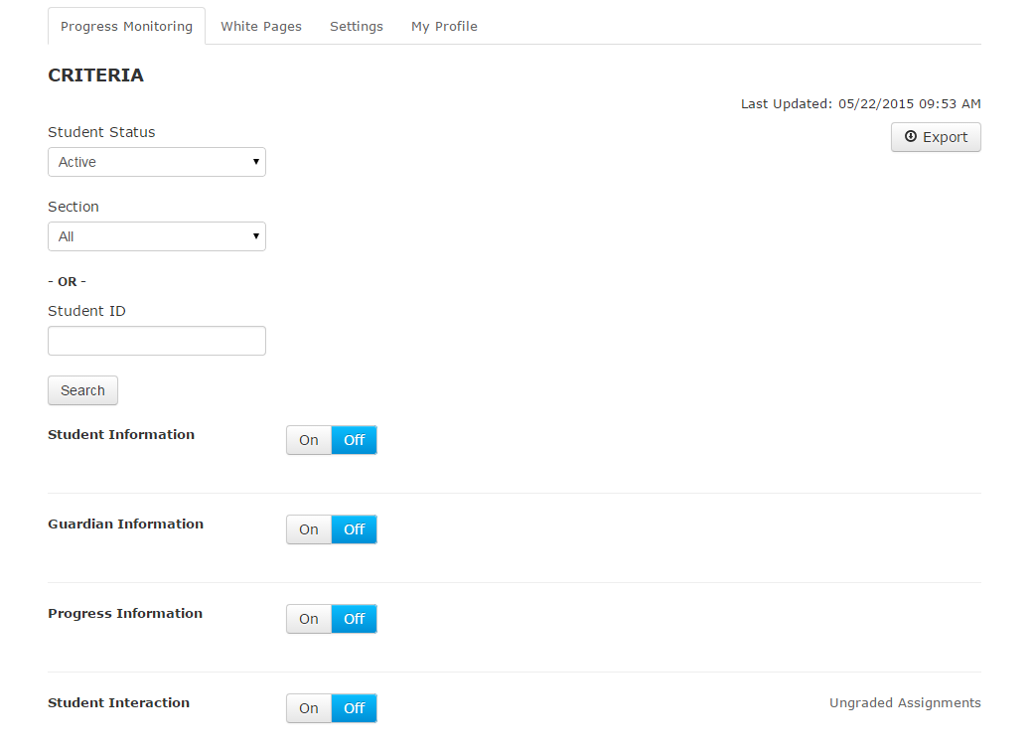

Each Table has a set of columns, the columns could be added thru administrator dashboard but they will only be available in one table Student Interaction Table:

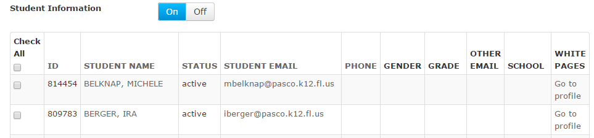

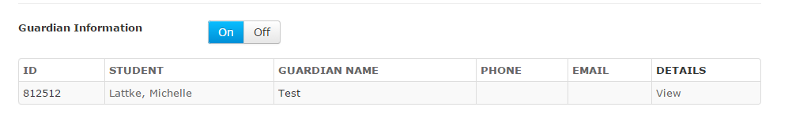

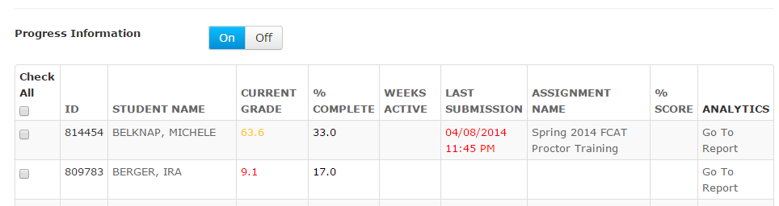

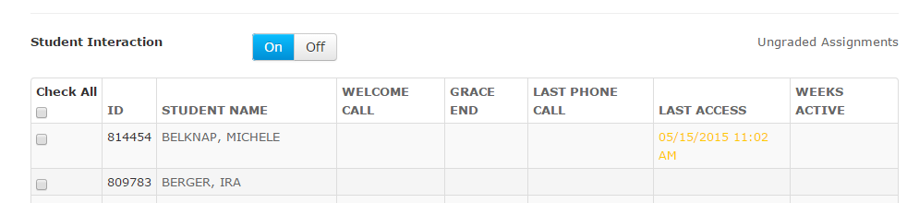

Future State:

Dynamic Tables will be introduced to end user.

**Set Up my Own View Use Case [first time creating my dashboard view]:**

1. User launches the Dashboard “Progress Monitoring” page. The page has only filter fields under Criteria.

2. User sets up Criteria fields

3. User clicks on Add Table

4. User Selects either default table from the available ones or clicks on New

1. Default Table is selected : Student Information or Guardian Information or other
   1. A table with default columns is placed on the page
   2. All columns are populated with available data
   3. Table could be turned on or off by using toggle button
   4. Message box is available when user selects a specific student record
2. A New table is selected
   1. User is presented with dynamic fields grouped by default table names
   2. Other dynamic fields group has all fields added by administrator as well as new Comment field [ all new fields will be added under this group in the future]
   3. User clicks on Add => a new custom table is added to the page view. If user selected New table as a second table [ after she added default table for an example] the new custom table will be able at the bottom of the previously added table
   4. User can save the new custom table by clicking on Save icon at the top right corner of the new custom table. As soon as the table is saved its name will appear on the list of Available Tables
   5. If User would like to remove a table from the view, user will use the Remove icon located by save icon at the top right corner of any tables on the page



Save and Edit My Dashboard view:

1. After end user placed all desired tables on the view, she will need to click on the Save icon located at the top of the dashboard progress monitoring page by Export icon

2. Every time end user visist dashboard –progress Monitoring Page she will be presented with the view she saved the first time the dashboard view was created

3. End user could always modify the default view by Adding new tables or removing existing ones, after user modifies she will need to save changes by clicking on the Save icon located at the top of the dashboard progress monitoring page by Export icon.

**Note:** all views and workflows presented in this task are subject to redesign during the development process, new workflows could be introduced if decided by development team and client. All wireframes are not final design and are subject to change. Instructure will conduct feedback sessions with client during development process to make sure all features are developed per client’s expectations.

5. New Ungraded Assignment View in Assignment Key LTI:



1. Assignment name, student name, and date column should be sortable.
2. Assignments should not be grouped by assignment name.

6. Improved Layout/Style for Wide Tables

Current State

The width of the LTI container is restricted to 1100px. This makes viewing tables with a large number of columns cumbersome.

Future State

Custom JavaScript will be utilized to override the 1100px max width restriction. The container will instead extend to far right edge of the browser window.

7. Rename White Pages

Current State

The term “White Pages” is used 1) in the user navigation area, 2) as a tab label when the tool is accessed within a course, and 3) as a link in the Student Information table (teacher view).

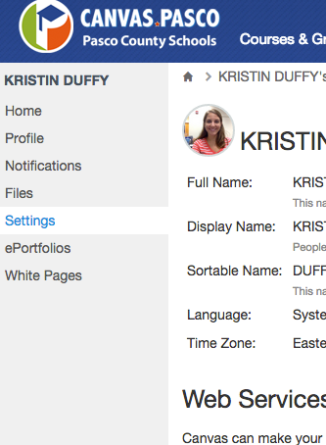

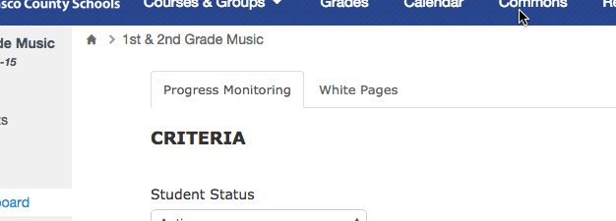

Future State

Rename “White Pages” to “Contact Info”. Note that access from the user navigation area will be removed as per the “Student Dashboard” enhancement.

8. Student Dashboard

Current State

Students do not have access to the Progress Monitoring functionality within a course. Students also have to go to their User Settings page to access the “White Pages” area—they cannot access the tool from directly within a course.

Future State

Students will have access to the eSchool Dashboard within each course they’re enrolled in. From this view, students will see a limited version of the existing Progress Monitoring tab, and selecting the “Contact Info” tab will show them their existing “White Pages” view.

***Progress Monitoring***

Filtering and “On/Off” switches will be removed, as the user will only see data related to themselves. Guardian Information will not be displayed, as it will be accessible from the Contact Info tab. The fields to be included in each of the remaining tables are outlined below. Each included field will be calculated and displayed exactly as it currently is from the existing teacher view.

***Student Information***

Note: New form fields added by admins will appear in this table if the “Add to Student Dashboard” option is selected

* Student Name
* Student Email
* Phone
* Gender
* Grade
* Other Email
* School

***Progress Information***

* Student Name
* Current Grade
* % Complete
* Weeks Active
* Last Submission
* Assignment Name
* % Score

***Teacher Interaction (renamed from Student Interaction)***

* Student Name
* Welcome Call
* Grace End
* Last Phone Call
* Last Access
* Weeks Active

